Geometry: Dieckmann/Kelly Name _________________________________
Unit 9 Area: Weekly #2 Kite & Rhombus Due: 4/4

Concept Extension:
1. The diagonals of a rhombus have lengths of 12 m and 16 m. What is the difference in the values of the perimeter and area of the rhombus? (2 points)
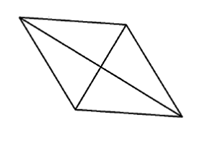

2. Two isosceles triangles share a common base but do not share any area. The sides of one triangle measure 5 inches, 5 inches, and 3 inches; the sides of the second triangle measure 10 inches, 10 inches, and 3 inches. Draw a picture and find the area of the figure formed by the two triangles. (2 points)

Algebra 2 Review: (1 point each)
3. What is the value of $x^{3}-x^{2}-x$ when x = -1? 4. Solve: $3\left(4-y\right)=12-2(5y-1)$

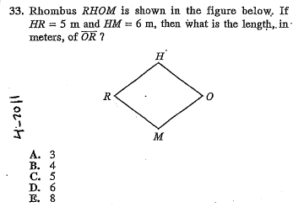
ACT: (1 point each)
