Dieckmann - Geometry Name ________________________________ Hour ________

**HWK #1 Special Parallelogram Due:**

1. Find the perimeter of a rectangle in which h = 8 in. and A = 28x sq. in.

Answer: 7x + 16

2. The area of the parallelogram



3*x* in.

Answer: 18x in

3. Find the perimeter and area of the following.

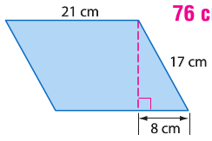

Answer:

Area: 315 cm2

Perimeter: 76 cm

4. Find the height of the parallelogram in which *A* = 182*x* in2.



Answer: 9.1 in

5. Find the area of a square in which the diagonal is $2\sqrt{6}$.

Answer: 12 units2

6. Find the area of the polygon with the following vertices A (1, 2), B (2, -1), C (5, 0), and D (4, 3).

Answer: $\sqrt{10}$