April/May 2016: Function Unit

Sun | Mon. | Tue. | Wed./Thurs. |  | Fri. | Sat.
10 | 11 | 12 | 13 14 |  | 15 | 16
 | Solving Linear Inequalities  Linear/Abs Value Weekly Due 4/25  HWK #1: Solving Linear | Writing Equations of Lines | QUIZ Solving Linear Equations/ Inequalities  Writing Equations of Parallel/Perpendicular Lines  HWK #2: Writing Equations of Lines/Graphing |  | NO SCHOOL!!!!
17 | 18 | 19 | 20 21 |  | 22 | 23
 | Graphing Linear Equations and Inequalities | Systems of Linear Equations  HWK #3 Systems of Linear Equations | Equations of Lines Quiz-Writing and Graphing  Solving Absolute Values/Inequalities  HWK #4: Absolute Value |  | Absolute Values Solving Quiz  Graphing Absolute Value & Inequalities  Review
24 | 25 | 26 | 27 28 |  | 29 | 30
 | QUIZ Absolute Values  Linear/Abs Value Weekly DUE!  Solving Radical Functions  Function Weekly  Due 5/9  HWK #5: Radicals-Solving and Graphing | Graphing Radical Functions | QUIZ Radicals  Review of Linear, Absolute Value and Radicals; Piecewise Functions |  | Function Notation  Adding/Subtracting Functions  HWK #6: Functions-Operations, Composition, Inverse
1 | 2 | 3 | 4 5 |  | 6 | 7
 | Multiplying Functions  Composition of Functions | Composition of Functions Review | Inverse of Functions |  | QUIZ Functions  Review for Function Unit Exam or Final Exam
8 | 9 | 10 | 11 | 12 | 13 | 14
 | ALL HOMEWORK IS DUE!  Quiz Retakes!  Review for Function Unit Exam or Final Exam | Seniors:  FINAL EXAM  Juniors: UNIT EXAM | Seniors: FINAL EXAM  Juniors: UNIT EXAM | Review for Junior Finals | Review for Junior Finals
15 | 16 | 17 | 18 | 19 | 20 | 21
 | Review for Junior Finals | Junior Finals Hours 2, 4, & 6 | Junior Finals;  1 & 3 | Junior Finals;  5 & 7 | No School!! Summer Vacation Begins

Algebra 3/Trig: Dieckmann Name: ___________________________
Function Notes
Linear
Linear Inequalities:
Inequality Symbols & What they mean

Solve & Graph the solution set on a number line
1) $5w+3>4w+9$
2) $-3\left(5-4r\right)≤-9$
3) $-5(y-7)≥25$
4) $-7x-8≤2-2x$
Solve the Inequalities, graph the solution set, and write it in interval notation
1) $8<3y-7≤23$ 2) $k+6<-4 or 3k≥15$
3) $-5≥3z-2>-14$ 4) $g-6>-11 or 2g+4<-15$
Writing Equations of Lines:

Slope-Intercept Form: Point-Slope Form:
- m is the ______________ m is the _______________
- b is the _______________ $x_{1}$is the ___________________________
$y_{1}$is the ___________________________

Write the equation of the line given the situations
1) (2, 3) and (4, 4) 2) (-4, 5) and (4, 3).

3) (6, -5) and (10, -5) 4) Slope of $\frac{-3}{5}$ and passes through (5, -2)

5) Slope $\frac{1}{2}$ and passes through (2, 3)

Write the equation of the line that is perpendicular and parallel to:
6) Slope of $-3$ and passes through (-2, -1) 7) Slope of $-3$ and passes through (-2, -1)

8)$2x-5y=8$, point (2, 7) 9)$-x-\frac{1}{2}y=4$, point (-2,-1)

Graphing Linear Functions and Inequalities:
Graph Functions in Standard Form
1) Graph: -2x + y – 4 = 0. 2) 3x – y + 6 = 0

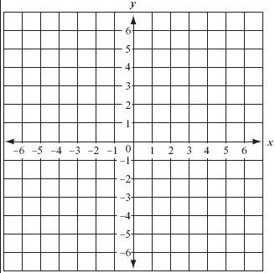

3) $y>-3x-2$ 4) $x+4y≥2$

Systems of Linear Equations:
What are the two methods of solving systems?
1) $\left\{\begin{aligned}4x-3y=-22 \\ 2x+3y=16\end{aligned}\right.$ 2) $\left\{\begin{aligned}6x-5y=-8 \\ 4x-5y=-12\end{aligned}\right.$ 3) $\left\{\begin{aligned}5x-3y=23 \\ y=-2x+7\end{aligned}\right.$

4) Levi has a job offer in which he will receive $800 per month plus a commission of 2% of the total price of the cars he sells. At his current job he receives $1200 per month plus a commission of 1.5% of his total sales. How much must he sell per month to make the new job a better deal?

5) A youth group went on a trip to an amusement park, travelling in two vans. In the first van, there were 2 adults and 5 children and it cost a total of $77 to enter the park. In the second van, there were 2 adults and 7 children and it cost $95. Find the adult price and the student price of admission.

Absolute Value
Solving Absolute Value Equations and Inequalities:
Evaluate the following:
1) $8.4-\left|2n+5\right|$ if n = -7.5 2) $\left|4x+3\right|-3.5$ if x = -2

Solve the following:
1) $\left|3x-2\right|+8=1$ 2) $\left|x+10\right|=4x-8$ 3) $8x=2\left|6x-2\right|$

4) $-3\left|3t-2\right|-12=-6$ 5) $2\left|x+1\right|-x=3x-4$

Solve and graph the solutions:
7) $\left|6y-5\right|≥13$ 8) $\left|4x-7\right|>13$ 9) $\left|5z+2\right|<17$

Graphing Absolute Value Equations:
1) $y+2=\left|x+2\right|$ 2) $-y+3=2\left|x-2\right|$

Domain: Domain:

Range: Range:

Transformations Transformations:

Vertex: Vertex:

3) $-2+y≤-\left|x-1\right|-2$ 4) $-3\left|x-1\right|+2≥2+y$

Domain: Range: Domain: Range:
Transformations: Transformations:
Vertex: Vertex:
Radical
Solving Radical Equations:
1) $2+\sqrt{x+5}=3$ 2) $\sqrt{5x+14}=x$ 3) $\sqrt{3x+5}=\sqrt{x+1}$

4) 5)

Graphing Radical Functions:
1) $f\left(x\right)=-2\sqrt{x+1}+3$ 2) $f\left(x\right)=\sqrt{x-2}+2$

Domain: Domain:
Range: Range:
Transformations: Transformations:

Function Notation
Function Notation:

Given the following graphs below find the indicated information.
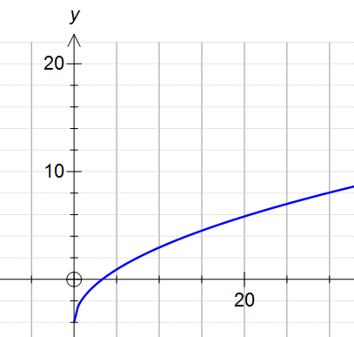
1. a) Is $f (1)$positive or negative?

b) Is the function even or odd?

c) X-Int: Y-Int:

d) How often does the line x = 1 intersect the graph?
How often does the line y = 2 intersect the graph?

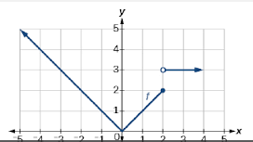
2. a) Is $f (1)$positive or negative?

b) Is the function even or odd?

c) X-Int: Y-Int:

d) How often does the line x = 1 intersect the graph?
How often does the line y = 2 intersect the graph?

Operations with Functions:
Given the following: $f\left(x\right)=-4x+1, g\left(x\right)=-x^{2}+x-4, h\left(x\right)=-2\left|x-4\right|+2$
A. $h\left(4\right)=$ | B. $g\left(-4\right)+h\left(1\right)=$ | C. $f\left(3\right)∙g\left(1\right)=$
D. $g\left(6\right)-f\left(-1\right)=$ | E. $f\left(x+2\right)$ | F. $g\left(-x\right)=$
1) Given $f(x) =\sqrt{x-2}+3$ and $g(x) = 2x^{2} – x – 1$, find (f + g)(x).

2) Given $f(x) = 3x+2$ and $g(x) = 2x – 1$, find (f – g)(x).

3) Given $f(x) = 2\left|x+2\right|-4$ and$g(x) = 8$, find (f + g) (x).

4) Given f(x) = 3x² – 2x + 1 and g(x) = x – 4, find (f ● g)(x).

Composition of Functions:
1) Find [f ○ g] (x) for $f(x) = 3x-10$ and$g(x) = 2x – 1$.

2) Find [g ○ f] (x) for $f(x) = \sqrt{x+3}-17$and$g(x) = 2x – 1$.

3) Find f (g(x)) for $f(x) = -3\left|x+12\right|-10$ and$g(x) = x + 5$.

Inverse Functions:
Step-by-step:
- Step 1 Replace f(x) with y in the original equation.
- Step 2 Interchange x and y.
- Step 3 Solve for y.
- Step 4 Replace y with f ^{–1}(x).
1) Find the inverse of $f\left(x\right)=-\frac{1}{2}x+1$ 2) Find the inverse of $f\left(x\right)=\frac{1}{3}x+6$

3) Find the inverse of $f\left(x\right)=x^{2}+6$ 4) Find the inverse of $f\left(x\right)=6(2x+4)$

