Algebra 3/Trig – Dieckmann Name
Linear Weekly Hour

Rough Draft Due Date: APRIL 21st Final Draft Due Date: APRIL 25th

INSTRUCTIONS: If you turn this in on the Rough Draft deadline or before, the problems will be checked and returned to you. You may then revise your work and turn in a final draft. You may turn in a rough draft one time per weekly. After the rough draft deadline, assignment is considered in its final draft and CANNOT be corrected for credit. Each Weekly assignment will have four questions worth five points each. Please be sure to circle/box your final answers and label each question.

This is my (circle one): ROUGH DRAFT FINAL DRAFT
1) Find the value of the slope between the points A and B. Show all your work.  $A (\frac{2}{n},\frac{1}{2})$ $B(\frac{1}{3},\frac{3}{n})$ | Rough Draft | Final Draft
 | Full Credit  Still needs work | Score:  /5
2) Write the absolute value inequality that represents the following expressions:  A) “x is 5 units or more away from 2”  B) “x is less than 8 units away from negative 3”  C) “half of x is more than 14 units away from 17” | Full Credit  Still needs work | Score:  /5
3) Find the area of the shaded area created by the system of inequalities. A graph has been provided for your convenience.  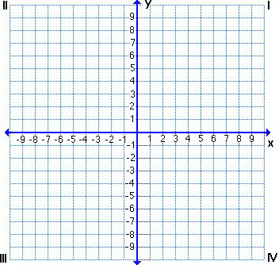 | Full Credit  Still needs work | Score:  /5

