Geometry: Dieckmann Name _________________________________

Hour ______

Area of Squares, Rectangles, Rhombi, Triangles, Trapezoids, Kites, Parallelograms

**Show all formulas, all work, and label your answers!!**

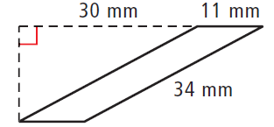

1. Find the area of the following parallelogram.

176 mm2

2. Find the height of a rectangle with a base of 2 inches and an area of 

(3x2 + 12x - 3) in

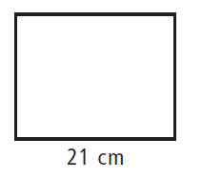

3. Find the height of a rectangle with an area of 

(3.8x2 – 2) cm

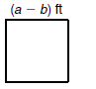4. Find the area and perimeter of the following square.

A: (a2 – 2ab + b2) ft2

P: 4a – 4b ft

5. The perimeter of a square 200 feet. What is the area?

2500 ft2

6. Find the height of a parallelogram with a base of 20x mm and A = 

9.1x mm

7. Find the perimeter of a rectangle with a height of 8 in. and A = 28x sq. in.

(7x + 16) in

8. Find the base of a triangle in which h = 8 cm and 

(3x + 2) cm

9. Find the area of a trapezoid with 

(45a + 18ac) in2

10. Find the area of the following triangle.

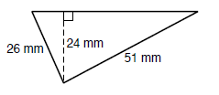

660 mm2

11. Find the height of a rectangle with a base of 2x ft. and 

5x ft

12. Find the area of a rectangle where b = (4x + 2) in. and h = (x – 1) in.

(4x2 – 2x – 2) in2

13. Find the area of a right triangle with a leg of 5 in. and a hypotenuse of 13 in.

30 in2

14. Find the area of an equilateral triangle with a side length of 9 cm. Leave your answer as a simplified radical.

20.25 $\sqrt{3}$ or 35.1 cm2

15. Find the area of a trapezoid with 

40.3 in2

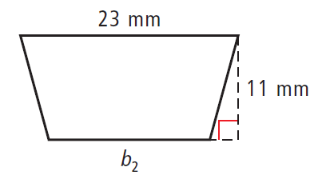16. Find the missing base of a trapezoid with an area of 231 sq. mm.

19 mm

17. Find  of a kite where and 

34 in

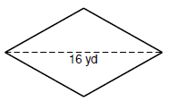18. Find  of a rhombus where A = 200 yd2

25 yd

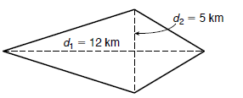19. Find the area of the kite.

30 km2

20. Find the area of a 30-60-90 triangle with a hypotenuse of 10 inches.

$12.5\sqrt{3}$ or 21.65 in2

Applications:

**SHOW YOUR FORMULA AND ALL WORK!!**

1. A rectangle has an area of 36 sq. in. and a length of 9 in. Find its perimeter.

26 in

2. A square has an area of 10,000 sq. m. Find its perimeter.

400 m

3. A triangle has an area of 48 sq. ft. and a base of 16 ft. Find its height.

6 ft

4. You are going to retile your floor. The floor in your kitchen is 12 feet by 15 feet. The 12 inch

by 12 inch tiles you’d like to use are on sale for $0.99 each. What will be the cost of the tiles

to cover your kitchen floor?

$178.20

5. A biologist is studying insect populations in a field. In a test **square** 10 feet on a side, he finds 30 green bugs. The whole field is 150 feet long and 220 feet wide. Estimate the total number of green bugs in the field.

90,000 bugs

6. The area of a trapezoid is 60 sq. in. If the longer base is three times the shorter base and the altitude is 5 inches, find the length of both bases.

6 in and 18 in

7. The area of a trapezoid is 64 sq. in. One base is 10 in. and the height is 8 in. Find the length of the other base.

6 in

8. The area of a parallelogram is 84 sq. in. The base is 14 in. Find the height.

6 in

9. The area of a triangle is 84 sq. in. The base is 12 in. Find the height.

14 in

10. The width of a rectangle is 9 cm. The diagonal is 25 cm. Find the area of the rectangle.

Round to the nearest tenth.

209.7 cm2