Algebra 3/Trig: Dieckmann Name: __________________________

HWK #5: Graphing Log and Exponential

**Graph the following logarithmic equations. State the transformations, y intercept, vertical asymptote, domain, and range.**

1. 2.

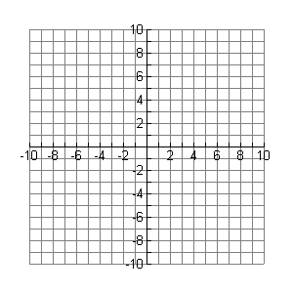

|  |  |
| --- | --- |
| **x** | **y** |
|  |  |
|  |  |

|  |  |
| --- | --- |
| **x** | **y** |
|  |  |
|  |  |

Transformation: Transformation:

Y – Int: _________ Y – Int: _________

Vertical Asymptote: __________________ Vertical Asymptote: __________________

Domain: _______________________ Domain: ________________________

Range: ________________________ Range: _________________________

3. 4.



|  |  |
| --- | --- |
| **x** | **y** |
|  |  |
|  |  |

|  |  |
| --- | --- |
| **x** | **y** |
|  |  |
|  |  |

Transformation: Transformation:

Y – Int: _________ Y – Int: _________

Vertical Asymptote: __________________ Vertical Asymptote: __________________

Domain: _______________________ Domain: ________________________

Range: ________________________ Range: _________________________

5. 6.

|  |  |
| --- | --- |
| **x** | **y** |
|  |  |
|  |  |

|  |  |
| --- | --- |
| **x** | **y** |
|  |  |
|  |  |



Transformation: Transformation:

Y – Int: _________ Y – Int: _________

Vertical Asymptote: __________________ Vertical Asymptote: __________________

Domain: _______________________ Domain: ________________________

Range: ________________________ Range: _________________________

7. 8.

|  |  |
| --- | --- |
| **x** | **y** |
|  |  |
|  |  |

|  |  |
| --- | --- |
| **x** | **y** |
|  |  |
|  |  |



Transformation: Transformation:

Y – Int: _________ Y – Int: _________

Vertical Asymptote: __________________ Vertical Asymptote: __________________

Domain: _______________________ Domain: ________________________

Range: ________________________ Range: _________________________