Algebra 3/Trig – Dieckmann Name
Logarithmic Weekly Hour

Rough Draft Due Date: MARCH 31st Final Draft Due Date: APRIL 4th
INSTRUCTIONS: If you turn this in on the Rough Draft deadline or before, the problems will be checked and returned to you. You may then revise your work and turn in a final draft. You may turn in a rough draft one time per weekly. After the rough draft deadline, assignment is considered in its final draft and CANNOT be corrected for credit. Each Weekly assignment will have three questions worth five points each. Please be sure to circle/box your final answers and label each question.

This is my (circle one): ROUGH DRAFT FINAL DRAFT

1) Solve the following equation. Show all your work.  $$4^{\log_{4}\left(3x+2\right)}=32$$ | Rough Draft | Final Draft
 | Full Credit  Still needs work | Score:  /5
2) Order the following from least to greatest:  A) $\log_{3}12$ B) $\log_{7}29$ C) $\log_{12}117$ D) $\log_{2}15$  Write the letter for each expression below:  ________ ________ _________ ________ ________ ________  (least) (greatest) | Full Credit  Still needs work | Score:  /5
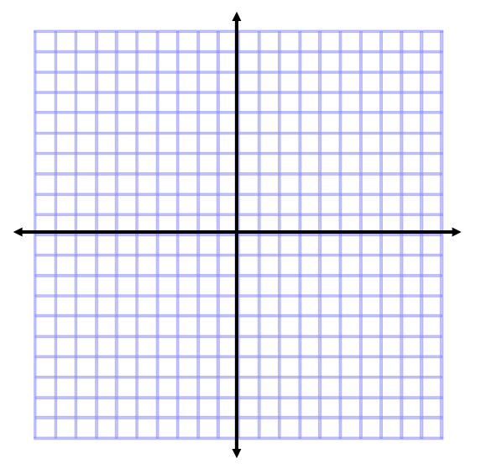  3) Graph the following exponential equation and logarithmic equation on the coordinate plane below. Use a graphing calculator to find where the functions intersect.  $$f(x)=4^{(x+2)}-3$$  $$g(x)=\log_{4}\left(x+3\right)-2$$  Intersection(s): ________________________________ | Full Credit  Still needs work | Score:  /5

