Dieckmann-Geometry Name: ________________________________ Hr: ___

**HWK #4 Circles (Due :_________)**

**Find each measurement.**

1. Find the radius of circle J if the C = 

Answer: (32.5x + 7) m

2. Find the circumference of circle M if the A = 

Answer: 10x ft

3. Find the area of circle D with a diameter of 8x feet.

Answer: 16x2 ft2

4. Find the radius of circle L in which 

Answer: 12 inches

5. Find the area of circle P in which C = 

Answer: 256 yd2

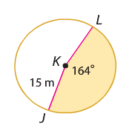Find the area of the following sectors in problem #8 -11.

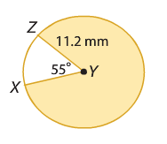

6. 7.

Answer: 60.19 mm2 Answer: 322.01 m2

Find the length of arc AB in problems #8-9.

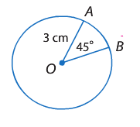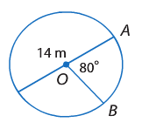

8. 9.

Answer: 2.36 cm Answer: 9.77 m

10. Find the radius of a circle with an ARC LENGTH equal to $16π$ cm and an angle of $90°$

Answer: 32 cm

11. Find the area of the circle with a center at (-2, 2) and passes through the point (2, 4)

Answer: 20 u2