|  |  |
| --- | --- |
|  |  |
|  |  |
| **March/April** 2016  Chapter 11 Area | |
|  |  |

|  |  |  |  |  |  |
| --- | --- | --- | --- | --- | --- |
| Sun. | Mon. | Tue. | Wed. Thu. | Fri. | Sat. |
| **20** | **21**  **No School- Teacher Professional Development** | **22**  Special Parallelograms  *Area Weekly #1: Special Due 3/28*  *HWK #1: Area of Special Parallelograms Due 3/25* | **23/24**  Special Parallelograms in the Coordinate Plane | **25**  **HWK #1 Due;**  **QUIZ: Special Parallelograms**  Triangles & Trapezoids  *HWK #2: Triangles and Trapezoids Due 3/28* | **26** |
| **27** | **28**  **HWK #2 Due;**  **QUIZ: Triangles & Trapezoids**  Herron’s Formula  *Area Weekly #2: Kite and Rhombus Due 4/4* | **29**  Area of Kites and Rhombi  *HWK #3: Kites and Rhombus Due 4/5* | **30/31**  Sophomore State Testing:  Review Area of All Figures and Composite Figures | **1**  Sophomore State Testing: Project | **2** |
| **3** | **4**  Sophomore State Testing: Project | **5**  **HWK #3 Due**  **QUIZ: Kites and Rhombus**  Area of Circles  *HWK #4: Circles Due 4/8* | **6/7**  Area of circles coordinate plane  Sector area and arc length | **8**  **HWK #4 Due**  **QUIZ: Circles**  Composite Area | **9** |
| **10** | **11**  Composite Area Review | **12**  Review | **13/1**  **Area Exam** | **15**  **No School-Professional Development Day** | **16** |

**GEOMETRY: Dieckmann** Name: _________________________ Hour: __

**Unit 9 Area: Chapter 11 Notes Packet**

**Part 1: Area of Special Parallelograms**

1. Find the area of a parallelogram whose base is 15x cm and height is 10x cm.

2. Find the base of a rectangle in which h = 7 in. and A = 28x sq. in.

3. Find the height of a rectangle with a base of 3 inches and an area of 

4. Find the area.

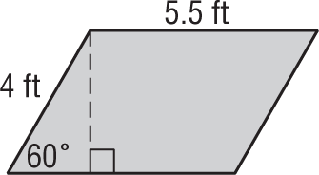

5. Given the points (3, 2), (4, 5), (3, 7) (4, 10). Determine the area of the figure.

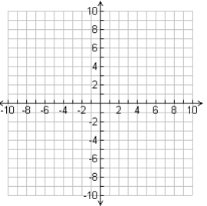

6. Find the area of a square in which the diagonal is $10\sqrt{2}$ cm.

**Part 2: Area of Triangles and Trapezoids**

1. Find the perimeter and area of the triangle.

2. Find the area of an equilateral triangle with side of 6 in.

3. Find of the trapezoid in which the $A=91 {ft}^{2}$, $b_{2}=10$ and the height is 14.

4. The base of a triangle is one half of its height. If the area of the triangle is 196 square millimeters,   
find its base and height.

5. Find the area

6. Find  of the following trapezoid where A = 4 sq. in.



**Part 3: Area of Kites and Rhombus**

1. Find the area of the rhombus.



2. Find the area of the kite.

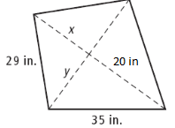

3. Find the perimeter of a kite in which the A = 49.92 sq. yds.



4. Find the area of the rhombus.



5. Find of the rhombus in which the A = 72x2 yd2 6. Find the area of the rhombus whose sides

are 8 m.

**Part 4: Area of Circles, Sectors and Arc Length**

1. Find the circumference of circle T in which A =

2. Find the diameter of circle L in which C = 

3. Find the radius of a circle in which A =

4. Find the area of a circle in which the center is at (4, 5) and a point on the circle is at (8, -1)



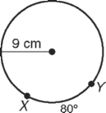5. 6.

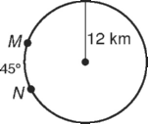

7. Find the area of the following shaded sector

